**PRESENTATION IN AUTOMATED PLANNING AND CONTROL AND GAMING AI AGENTS**



**JOMO KENYATTA UNIVERSITY OF AGRICULTURE AND TECHNOLOGY**

## GROUP MEMBERS

CHARLES MARIGA SCT221-0495/2017

JOEL KUIYAKI SCT221-0914/2016

NELSON MBAU SCT221-0100/2017

**Automated, planning and control**

Automation: It’s a technique of making an apparatus, a process or a system to operate by itself with little or no direct human control.

Planning: The process of making arrangements for something.

Control: The power to influence a decision.

Therefore, automated planning and control is a branch of AI that involves coming up with strategies or action sequences for execution by intelligent agents e.g. (Autonomous robots and unmanned cars), packing robots in a factory/warehouse. Some of the application include: scheduling car for give parking lot.

Learning algorithms that are used in automated planning include:

* Induction programming
* Exception based learning
* Reinforcement learning
* Dynamic programming

**Importance of Planning and control**

There are two different importance where one is scientific and the other is engineering goal. **Scientific Goal**: it is to understand intelligence. This is an important component of rational (intelligent behavior).

**Engineering goal**: To build intelligent entities. Build planning software for choosing and organizing actions for autonomous intelligent machines.

**Types of planning and control techniques**

**Domain specific planning and control** - Uses specific representations and techniques adapted to each problem. It is used specific problems where highly efficient solutions are required.

**Domain independent planning** - it uses generic representation and techniques and is normally used with situations that are new to the AI agent.

ROBOTS

Planning is used in robots where it involves path and motion planning, perception planning, navigation planning, motion planning.

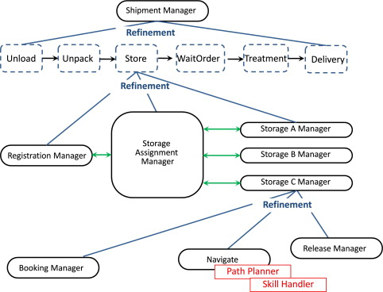

**Gaming AI Agents**

Intelligent systems are technologically advanced machines/programs that can perceive and respond to the world around them. In the case of game AI agents, this is the virtual game world.

Intelligent systems in gaming AI, using methods such as machine learning and neural networks, lead to an increase in realism of the AI agents, hence more immersive gameplay for the gamer. In whatever genre of games, there are always AI agents (Also referred to as Non-Player Controlled characters, or NPCs in short). Rudimentary techniques of implementing these agents, like Finite State Machines, often work, but have their shortcomings. Finite State Machines is the method where the AI designer comes up with all the states that an agent can be in, and all the factors that can make them move from one state to another. The major shortcoming is that the agents tend to be predictable since they have a finite number of states, and thus prove easy for the player to crack and defeat.

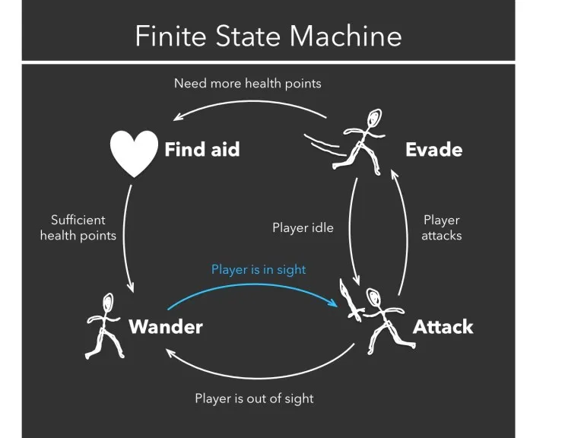

Example of a finite state machine

However, using intelligent systems means that the agents learn how to respond to various stimuli dynamically, hence their behavior is highly realistic and not mapped to a finite number of states. The use of intelligent systems in gaming AI agents leads to a highly personalized gaming experience, as seen in the game Petz, a game to train a digital pet. Since training styles differ between players, the pet learns how to respond to the player’s training, leading to a strong bond between player and pet. Intelligent systems also apply in other genres of gaming, even though they have not been widely adopted due to numerous reasons. For example, in First Person Shooter games like Battlefield and Call Of Duty, intelligent agents can learn how the player plays the game and the techniques they use, and thus adapt themselves to the gameplay. The enemies might use this information to adapt to defeat the player, and teammates might learn these techniques from the player and adapt to use them to defeat the enemies.

As seen, intelligent systems can be used in creating intelligent gaming AI agents that respond to the user and dynamically learn and program themselves to respond to user actions, thus leading to more immersive gameplay for the gamer. The use of neural networks and other machine learning techniques that have come up in recent years makes this possible.

**References**

Davies, N. P., & Mehdi, Q. H. (2006). BDI for intelligent agents in computer games. *Proceedings of CGAMES 2006 - 8th International Conference on Computer Games: Artificial Intelligence and Mobile Systems*, 104–107.

Dignum, F., Westra, J., Van Doesburg, W. A., & Harbers, M. (2009). Games and agents: Designing intelligent gameplay. *International Journal of Computer Games Technology*, *1*. https://doi.org/10.1155/2009/837095

Franklin, D. M., & Markley, K. (2014). Multi-agent artificial intelligence in pursuit strategies: Breaking through the stalemate. *Proceedings of the 27th International Florida Artificial Intelligence Research Society Conference, FLAIRS 2014*, 250–254.

Lee, C. S., & Teytaud, O. (2011). Intelligent agents for games and computer Go. *IEEE SSCI 2011 - Symposium Series on Computational Intelligence - IA 2011: 2011 IEEE Symposium on Intelligent Agents*, 1–2. https://doi.org/10.1109/IA.2011.5953622

Miikkulainen, R., & Miikkulainen, R. (2006). Creating Intelligent Agents in Games. *Proceedings of the National Academy of Engineering 20006 Conference on Frontiers of Engineering*, *2004*(Ml), 1–7. http://citeseerx.ist.psu.edu/viewdoc/summary?doi=10.1.1.99.8303%7B&%7Drep=rep1%7B&%7Dtype=pdf

(Miikkulainen & Miikkulainen, 2006)(Franklin & Markley, 2014)(Dignum et al., 2009)(Davies & Mehdi, 2006)(Lee & Teytaud, 2011)